**Technical Interview**

The following is a slimmed down version of a loan application manager. Please use the included code solution to write the functionality of the dashboard. Some of the features already work for you in the included solution. Others will need to be implemented by you. The solution uses Angular and C# (dotnet core), which is the code stack we use at GOLDPoint Systems (GPS).

Once you have completed this project and submitted your code to GPS, we will schedule an interview with you to go over your code and do a mock code review as your technical interview.

**Description of Functionality**

* You will store and update all data in a JSON file to simulate a database
* **MAIN PAGE**
* Display a table with the columns: “Application Number”, “Amount”, “Date Applied”, and “Status” on the main page (we have provided this page’s HTML and CSS)
  + Each table row should have a 3-dot menu icon that opens a dropdown menu with the options to edit or delete an application
  + Please provide a delete feature for each table row
    - A pop-up dialog must appear to confirm deleting an application
    - Delete must remove the application dynamically from the table in the UI and update the JSON file
  + Clicking edit in the menu should route you to an edit application page
  + Clicking the Floating Action Button (FAB) in bottom right corner of page should route to the edit application page, but with all blank fields to allow the user to create a new application
* **EDIT APPLICATION PAGE**
* Ability to edit an application (we provided the HTML and CSS for this page, you need to write the functionality)
  + Display all Loan Application data for the specific application being edited
  + Header should display “Create Application" (if creating) or “Application <ApplicationNumber>" (if editing) with a back arrow icon that takes the user back to the main page
  + Ability to edit first name, last name, email, and phone
    - First and last name should be required
    - Email should validate that it is a proper email address
    - Phone should be 9 digits with no special characters
  + Ability to update Amount or Term
    - Changing the amount or the term should update the MonthlyPaymentAmount field (Monthly Payment Amount is amount divided by term)
  + Ability to select different Status in drop-down (values: ‘New’, ‘Approved’, or ‘Funded’ only)
  + Display error messages when required fields are not set or fields contain invalid data
  + MonthlyPaymentAmount should be read-only
  + ApplicationNumber should be read-only if editing, but settable if creating
  + Save changes made (update JSON file)
    - Save should pop-up a snackbar saying “Saved successfully.”
    - Create should pop-up a snackbar saying “Created successfully.”

**Loan Application Object Description**

**Figma Prototype**

https://www.figma.com/proto/CkRwyrcEljzOjlnMEgrH5M/GOLDPoint-Interview---Application-Manager?node-id=2%3A1845&scaling=min-zoom&page-id=0%3A1&starting-point-node-id=2%3A1845

**Design Mocks**

**Landing Page**

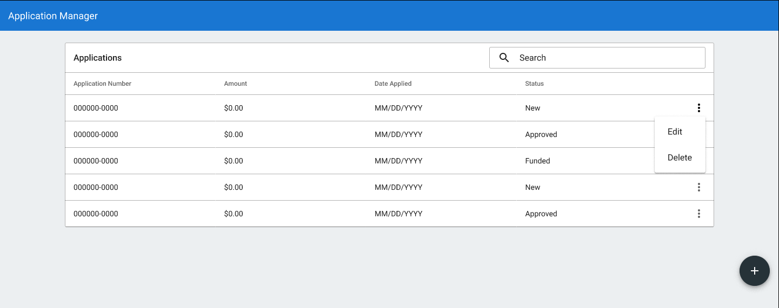

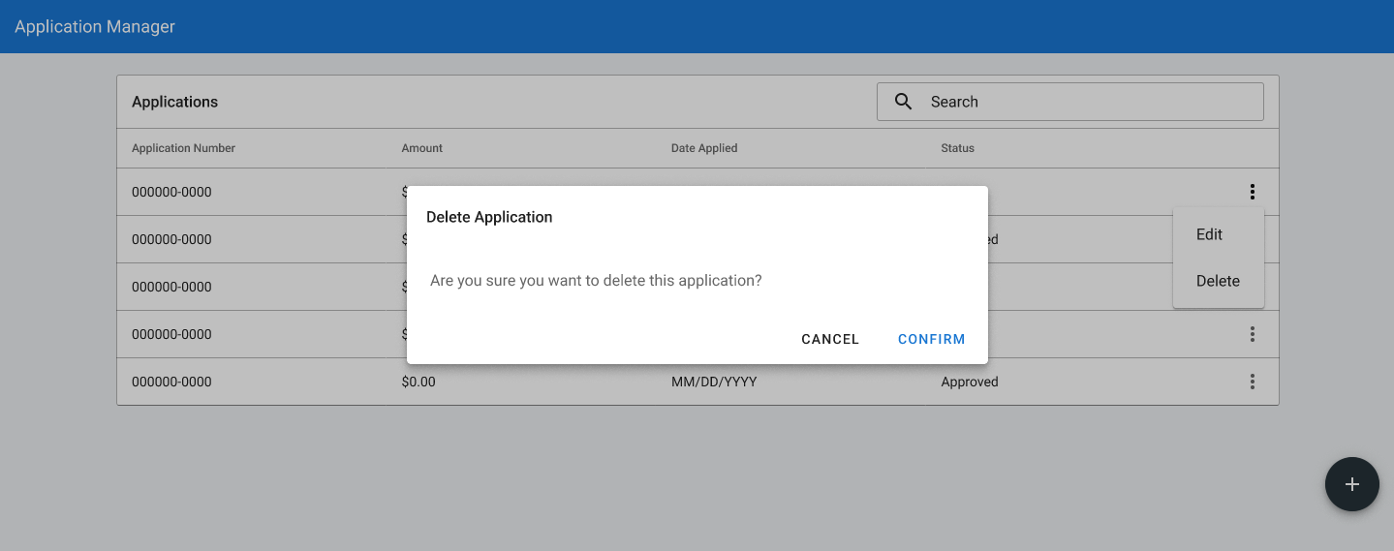

**Edit Application**

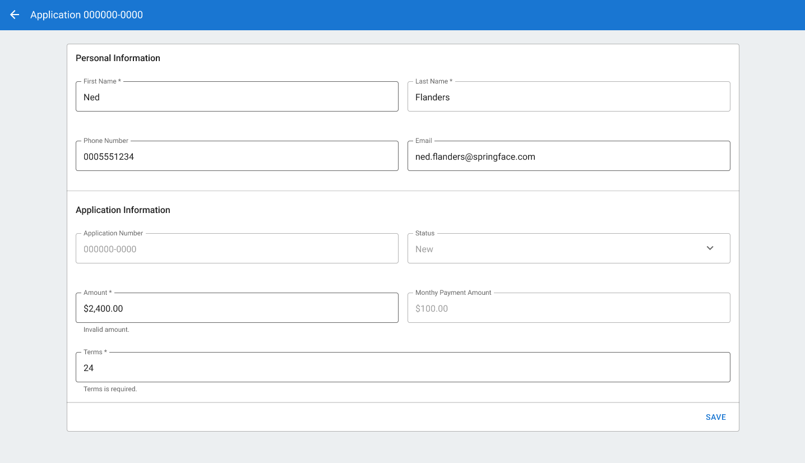

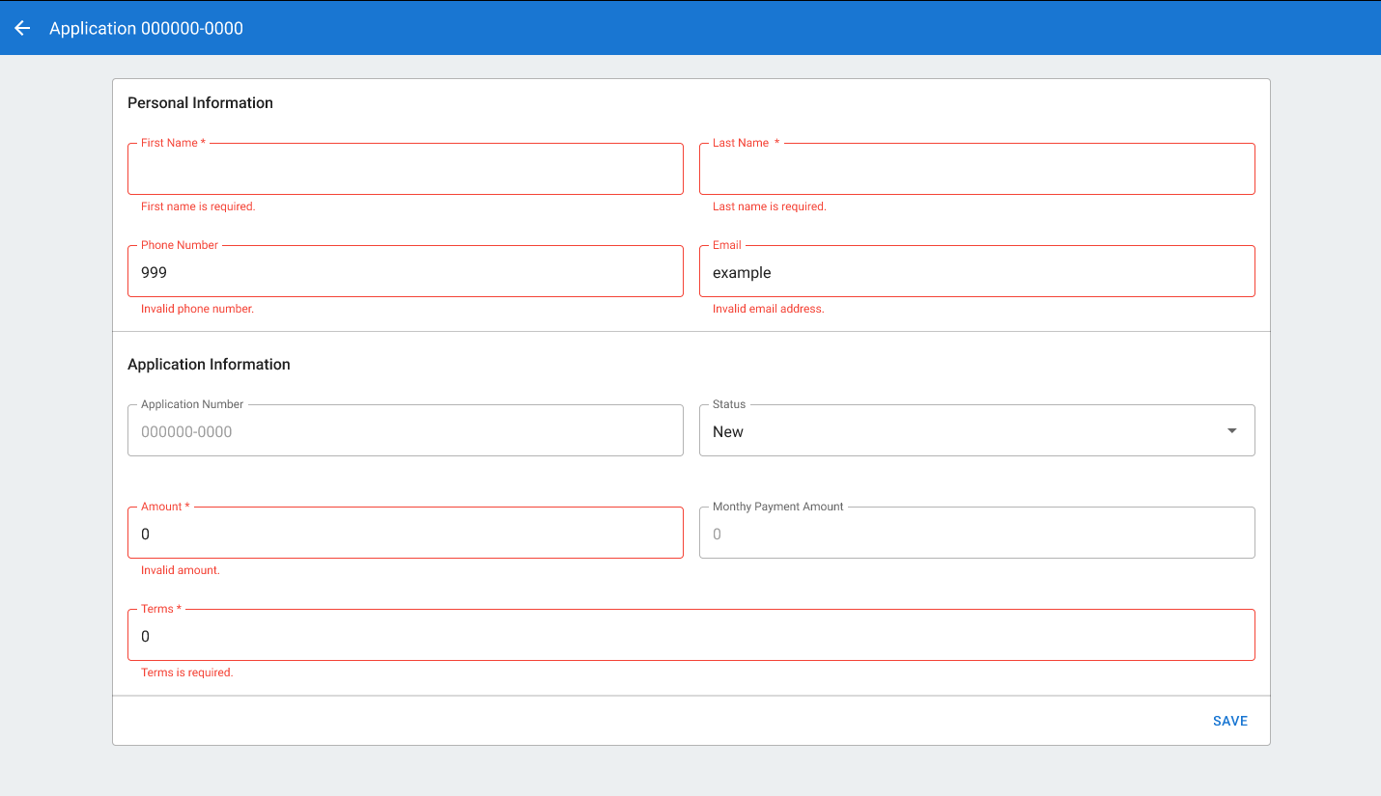

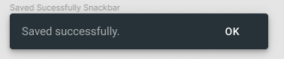

**Create Application**

